Peel Town Centre Parking Study and Parking Policy Development Options

Peel Town Commissioners Study – Isle of Man Step Programme

July - August 2025

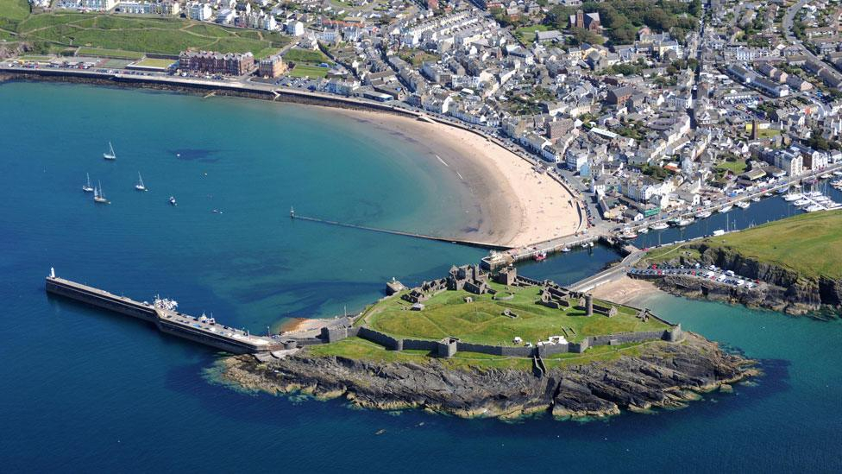

Study Conducted by: Jamie Casson

THIS PAGE IS INTENTIONALLY BLANK

List of Contents Page
- Introduction 4

  - Overview 4

  - Previous Studies/Literature Review 5-8

  - Study Objective 8-9

  - Report Structure 9-10

- Current Parking Situation and Survey Results 10

  - Introduction 10-11

  - Existing Parking Off-Street Supply 11-13

  - On-Street Parking Supply 13-18

  - Methodology and Survey Results 18-40

  - Other Comments 40-41

- Policy Development and Recommendations 42

  - Introduction 42

  - Town Centre Recommendations 42-47

  - Promenade and Town Outskirts Recommendations 48-52

  - Conclusion 53

Appendix 54

Bibliography 55-58
1 Introduction

  - Overview
This report was commissioned in July 2025 to conduct a parking and public transportation study for Peel Town Centre. This study has three chapters outlining different aspects of the study. Chapter one included an introduction to the study and outlined key literature and strategies undertaken by similarly sized towns within the UK. Chapter two involved outlining and conducting the occupancy beat surveys on the on- and off-street parking in Peel. This section includes calculations of occupancy rates and graphics highlighting turnover/availability of spaces throughout the whole of an average weekday and Saturday to understand the behaviour of the individuals using car parks. Chapter three outlines potential future parking policies and recommendations for the future supply and management of on- and off-street parking within Peel Town. This report was completed and presented to the Peel Town Commissioners in August 2025.

    - The study was informed by:
- A previous study on Peel Town Centre Parking and proposals /recommendations.
- Detailed on- and off-street parking surveys (Occupancy and Beat Surveys)

  - Previous Studies/Literature Review
    - In 2002, the Peel Town Commissioners undertook an in-house study to consider issues surrounding the provision of adequate parking within the town. The report put forward a simple business case for various options to form the basis for further discussion on the subject.

    - A study was conducted in September 2011 by Amey/Tpi to investigate and assess current parking conditions, street audits, and future policy developments. This was carried out in three stages: evaluating the current state of on- and off-street parking, conducting a street audit to test suitability, and developing future parking strategies or options based on current demand and supply in the town. They found that there were 1,653 available spaces within Peel; however, surveys showed that 30% of vehicles overstayed within restricted zones, along with high levels of other forms of illegal parking. Occupancy tests on various days of the week were undertaken to quantify current demand for spaces and forecast future needs, considering growth factors such as the expected increase in households. The study also identified strategy options to maintain a reasonable capacity ratio of 85%. (amey, 2013)

    - Literature Review: Policy Developments easing Demand

A review of parking strategies and legislation in smaller towns like Peel Town Centre reveals similarities to practices in the UK (Legislation.gov.uk, 1988). In the Isle of Man, under the Road Traffic Act (1985), boroughs can issue orders to register off-street parking facilities and adjust pricing. Parking management has become an increasingly significant issue in many UK towns and the Isle of Man, prompting research into solutions through policy or infrastructure (Keswick Town Council, 2020; Burnley.gov.uk, 2010; Hertsmere.gov.uk, 2022; Transport Planning International, 2011).

The town has many residents who frequently use its facilities, and a key topic of debate was the proposal to implement a two-hour disc zone on the promenade, as residents argued that this could cause more problems than it solves (isleofman.com, 2022).

Developments like these are often proposed and then abandoned due to local resistance and a lack of supporting evidence. Nonetheless, innovations in policy development by Keswick Town Council (2020) have focused more on redistributing high-demand parking through improved signage and flexible pricing strategies to shift demand to underused spaces, rather than simply restricting access.
Currently, in Peel, some on- and off-street parking areas are heavily used by residents—including areas that would typically be subject to restrictions. This reduces turnover and limits the availability of short-term parking for visitors. Better redistribution of parking demand through improved policy and infrastructure could make these spaces more equitably shared, supporting local businesses and the vitality of the town centre.

Many councils also prioritize demand management through pricing and supply controls. For example, Burnley Borough Council’s Parking Strategy (2010) aimed to create a more sustainable and cost-effective pricing system that discourages long-term parking in central areas and generates revenue for future infrastructure projects. These funds can be reinvested into public transportation, pedestrian infrastructure, or the development of peripheral parking facilities that better accommodate longer stays.

Similarly, Hertsmere Borough Council (2022) outlined goals for parking policy as a tool to support economic recovery, improve air quality, and promote behavioural change. Here, flexibility in pricing, clearer zoning, and enforcement are key strategies to influence parking habits and improve access to the town centre.

In conclusion, the broader literature suggests that an effective approach to managing parking in small towns with increasing visitor numbers combines policy measures such as zoning, pricing, signage, and enforcement. The experiences of towns like Keswick and Burnley demonstrate that data-driven decision-making, public consultation, and iterative implementation can create policies that are sustainable and publicly accepted. Peel Town Centre can benefit from adopting these approaches by tailoring them to the island’s specific legislative environment, local expectations, and spatial limitations—aiming to balance residents' needs with those of visitors and maintain the vitality of the town centre.

  - Study Objectives

    - This report responds to several objectives as set out in the current study brief, which are to:
- Observe and measure the existing parking Demand and Supply;
- Recommend parking standards/strategies for the study area via literature review;
- Identify whether recommendations from the Amey report have been effective;
- Identify areas within the area with current parking shortfalls/difficulties; and
- Develop/Evaluate policy options for Parking Management within Peel.
    - The established study area within which car parking should be considered, shown in Figure 1.
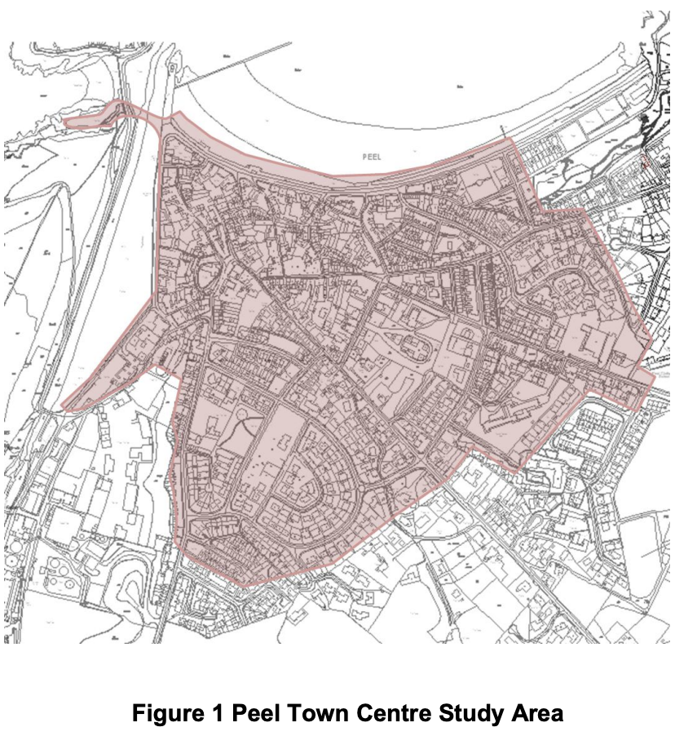

  - Report Structure
    - The results for the parking occupancy beat surveys are shown and analysed in Chapter 2. Chapter 2 outlines the current supply of spaces within the town and outlining the methodology undertaken and presentation of the data. Chapter 3 highlights the potential development options for improving or managing the current parking environment within the town’s study area.

2 Current Parking Situation and Survey results

  - Introduction
    - Peel is a small town on the Isle of Man that currently faces challenges in providing parking (3FM, 2024; Manx Radio, 2023; Amey, 2013). The study will review the current parking strategy and policies (July - August 2025). This study will involve assessing the number of on- and off-street parking spaces available in the town and testing the capacity rates throughout the week to see how long cars stay parked. These tests should reveal the parking characteristics in the town, especially on a typical Saturday and Friday when demand is usually highest, which generally applies across Europe according to Pasaoglu et al. (2012).

    - Any surveys and analysis undertaken will only provide a snapshot, which may not be representative of other periods on the island. For example, the situation of TT will not be examined in this study. and therefore, further data would need to be obtained; however, the data obtained should be representative of normal conditions.

    - Assuming we take demand for parking as a function of the number of journeys made by individuals in a private car, and this is steadily increasing due to the increased availability to purchase cars (Parmer, 2020), with standards of living growing year on year on the island (Gov.im, 2024). These are also affected by other variables, which have varying effects (Yan, 2019; Young et al., 1991).

- Trip Purpose.
- Search times for finding a spot.
- Disc Zone Time Constraints or Fees.
- Availability of alternative forms of transport.

  - Existing Parking Supply
Off-Street Supply
    - Table 2 shows the number of off-street parking spaces, and their locations are highlighted in Figure 2 below. The off-street car parks are controlled either by the local authority or by private organisations (Within Peel town centre).
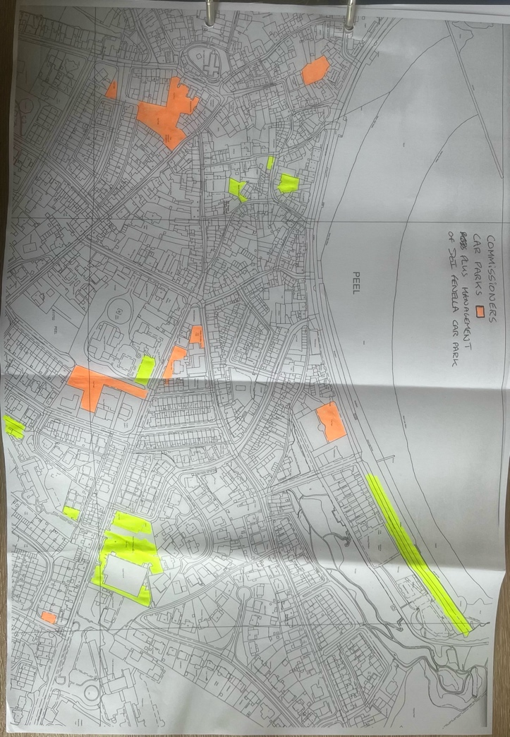
Figure 2: Off-Street Parking Areas Scoped In

    - As outlined in Table 1 below, currently, within Peel, 14 public off-street car parking areas contain 504 parking spaces. There is 1 additional private publicly available car park (116 Spaces), and 2 private non-residential areas, which combined provide 56 spaces. For further details on each of the parking areas, Figure 2 outlines the location of each car park, whilst Table 1 goes into further detail on each car park.
Table 1: Number of Off-Street Parking Spaces
Ref | Location | No. of Spaces
Ref | Location | Standard | Disabled | E-Parking
1 | Car Park off Victoria Street | 23 | 0 | 0
2 | Car Park off Douglas Street | 99 | 7 | 0
3 | Car Parks Strand Street | 23 | 1 | 0
4 | Car Park off Victoria Street | 25 | 2 | 0
5 | Victoria Road Car Park | 70 | 3 | 0
6 | Christian Street Car Park | 16 | 0 | 0
7 | Car Park off Derby Road | 69 | 0 | 0
8 | House of Manannan | 52 | 3 | 0
9 | Fenella Beach Car Park | 65 | 0 | 0
10 | Cathedral Car Park | 15 | 0 | 0
11 | Commissioners front Car Park | 13 | 1 | 0
15 | Derby Drive Car Park | 21 | 0 | 2
16 | West Quay Car Park | 8 | 0 | 0
17 | Kerroo Coar Car Park | 10 | 0 | 0
18 | Boilley Spittal Car Park | 8 | 0 | 0
Total: |  | 494 | 17 | 2
12 | Tesco Car Park | 110 | 6 | 0
Total: |  | 110 | 6 | 0
13 | Lancaster Funeral Directors | 10 | 0 | 0
14 | Health Centre Car Park | 44 | 2 | 0
Total: |  | 54 | 2 | 0
Total Per Type: |  | 658 | 22 | 2
Grand Total: |  | 682

  - On-Street Supply
    - Figure 3 below outlines the current on-street parking areas scoped for the survey tests in the town centre. Figure 3 will be colour-coded to highlight whether restrictions are present along the curb.

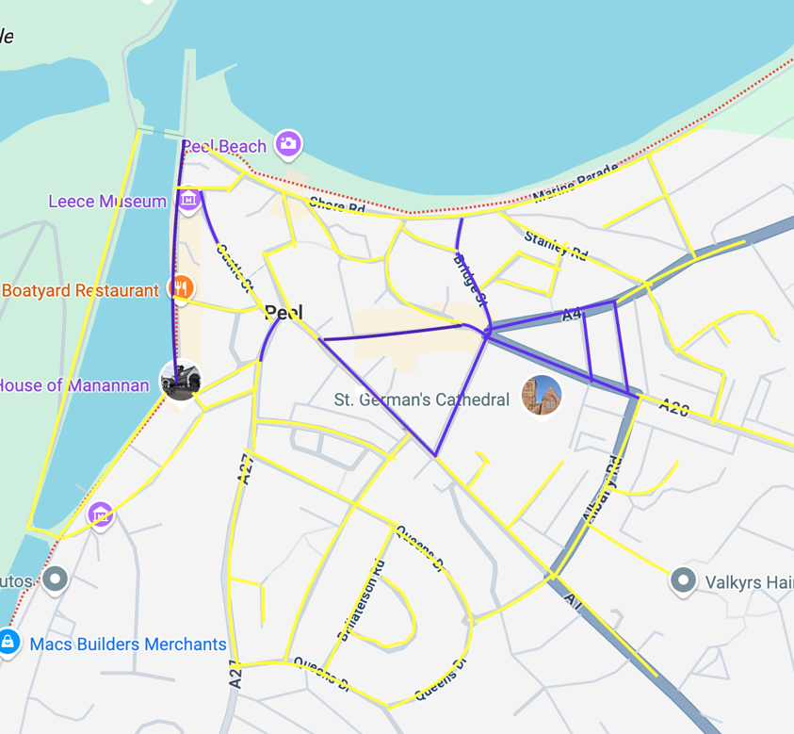
Figure 3: On-Street Parking Areas Scoped In
Key:

Non-Restricted

Restricted Disc Zone

Along the curbs in Peel there are several categories of restrictions:
- Restricted (30mins Disc Zone);
- Restricted (2 hours Disc Zone);
- Restricted between Times and Days;
- Unrestricted; and
- Disabled Bays.

    - On the following route in Figure 3, in scenarios where individual spaces are not defined, known as “uncontrolled areas” where there are no traffic lights, road markings, or signs indicating right of way (Perri and Vaiana, 2022). The study will count a parking space based on a nominal length of 6m, as this is the current standard size for a parking space (legislation.gov.im, 2025).

    - As outlined in Table 2 below, currently on the streets within Peel town centre, a combination of restricted, unrestricted, and disabled parking. Within the study area, there are 7 on-street 30-minute restricted spaces, 67 on-street 2-hour restricted spaces, 983 on-street unrestricted spaces, 27 on-street restricted spaces (Between Monday and Friday, 9:00-17:00), and 10 designated disabled spaces on-street.

Table 2: Number of On-Street Parking Spaces Categorised by Restrictions
Street Name | Restricted  (30 Minutes) | Restricted  (2 Hours) | Unrestricted | Restricted Between Times and Days | Disabled Bays
Albany Close | 0 | 0 | 25 | 0 | 0
Albany Road | 0 | 0 | 0 | 0 | 0
Atholl Street | 0 | 11 | 4 | 0 | 0
Atholl Place | 5 | 0 | 1 | 0 | 2
Ballaterson Crescent | 0 | 0 | 42 | 0 | 0
Ballaterson Road | 0 | 0 | 44 | 0 | 0
Beach Street | 0 | 0 | 5 | 0 | 0
Boilley Spittal | 0 | 0 | 50 | 0 | 0
Bridge Street | 0 | 15 | 3 | 0 | 0
Castle Street | 2 | 0 | 4 | 0 | 0
Christian Street | 0 | 4 | 6 | 0 | 0
Church Street | 0 | 0 | 0 | 14 | 0
Close Cubbon | 0 | 0 | 39 | 0 | 0
Crown Street | 0 | 0 | 11 | 0 | 0
Derby Drive | 0 | 0 | 29 | 0 | 0
Derby Road | 0 | 4 | 13 | 0 | 0
Douglas Street | 0 | 0 | 1 | 0 | 1
Duke Street | 0 | 0 | 0 | 0 | 0
East Quay | 0 | 4 | 31 | 0 | 3
Lyndale Avenue | 0 | 0 | 40 | 0 | 0
Factory Lane | 0 | 0 | 0 | 0 | 0
Glenfaba Road | 0 | 0 | 45 | 0 | 0
Heathfield Drive | 0 | 0 | 18 | 0 | 0
Lake Lane | 0 | 0 | 3 | 0 | 0
Lane off Glenfaba Road | 0 | 0 | 9 | 0 | 0
Market Place | 0 | 20 | 4 | 0 | 0
Market Street | 0 | 0 | 2 | 0 | 0
Michael Street | 0 | 0 | 0 | 7 | 0
Mill Road | 0 | 0 | 0 | 0 | 0
Mona Street | 0 | 11 | 0 | 0 | 0
Mount Circular Road | 0 | 0 | 18 | 0 | 0
North View | 0 | 0 | 20 | 0 | 0
Patrick Street | 0 | 0 | 51 | 0 | 0
Peveril Road | 0 | 0 | 0 | 3 | 0
Queen Street | 0 | 0 | 8 | 0 | 0
Queens Drive | 0 | 0 | 100 | 0 | 0
Shore Road | 0 | 0 | 64 | 0 | 0
St Peters Church | 0 | 0 | 0 | 0 | 0
Stanley Mount | 0 | 0 | 18 | 0 | 0
Stanley Road | 0 | 0 | 23 | 0 | 0
Station Place | 0 | 0 | 2 | 0 | 0
Station Road | 0 | 0 | 0 | 0 | 0
Strand Street | 0 | 0 | 7 | 0 | 0
The Grove | 0 | 0 | 8 | 0 | 0
Tynewald Road | 0 | 0 | 42 | 0 | 0
Victoria Road | 0 | 0 | 13 | 0 | 0
Walpole Road | 0 | 0 | 27 | 0 | 0
West Quay | 0 | 0 | 45 | 0 | 0
Westlands | 0 | 0 | 31 | 0 | 4
Westview | 0 | 0 | 75 | 0 | 0
Total: | 7 | 69 | 981 | 24 | 10
Total No. Spaces: | 1,091

    - The total number of on- and off-street spaces is likely to be an underestimate due to some spaces being hidden and not visible from ground reviews. Note that there are also several larger vehicles parked on-street within Peel, which would skew the total capacity of spaces on the street.

    - Tables 1 and 2 show that the total number of parking spaces available to the public in Peel Town Centre is 1,715, of which 33 are reserved for drivers with disabilities and 7 are reserved for electric vehicle charging/parking.

Notable Changes Since 2013 Report
    - Within the study conducted by Amey (2013), we can see that the total number of on-street spaces was 1,096, which has fallen by 10.3%. This is due to several observations, the first one being an increased level of enforcement and clearer road markings. Areas such as Shore Road, Heathfield Drive, and Station Place have seen changes in the number of spaces due to the implementation of new road markings, including double yellow lines that permanently prevent cars from parking or waiting on these curb sides (Gov.im, 2018). However, recent developments have included introducing designated 7 parking areas and bays for electric vehicles in already existing spaces (along East Quay). These spots are all restricted to 2 hours of charging, as most residents with such vehicles have charging stations fitted at their residences. The old unrestricted spaces were then moved further down the Quay, nearer the House of Manannan, increasing the overall supply slightly.

  - Methodology and Surveys
This is a type of survey that counts the number of vehicles staying within a car parking facility or on-street for a specified period to identify the peak and average demand for a space and is a commonly used methodology for data collection (Tong, Wong, and Leung, 2004; Morency and Trépanier, 2008; Dey et al., 2017). To understand the current demand during specific times, total capacity and occupancy rates were manually estimated (Based on Tables 1 and 2). This research will survey the town on- and off-street parking between 07:00 am and 7:00 pm, obtaining occupancy rates and assessing parking turnover within the period. Using these rates, the study will estimate current demand levels. All on- and off-street areas with proximity to the town will be selected for 30-minute beat tests, as the turnover within these districts is regular due to the time restrictions on the spaces. All other areas which contain unrestricted spaces or are not considered to be used for town parking will have an hour beat period. During these manual surveys, current occupancy will be noted, and live photos will be taken to identify turnover between each given interval beat.

    - Duration Surveys and Beat Tests
Beat surveys refer to a method of assessing parking, such as the duration of stay period and occupancy at a given specified period. This involves manually counting and recording parked vehicles at predetermined intervals (e.g., hourly, every 2 hours) along a designated route (TrafficWatch, 2020; Alpha Parking, 2022). For this survey, a predetermined interval will be based on the type of restriction present; for instance, spaces within the town centre will be tested on a shorter beat as vehicles are more likely to depart from spaces compared to those on unrestricted spaces. The manual surveys were conducted in routes and on specified days. Route 1, outlined in Figure 4, was conducted on 18th & 19th July to represent normal demand for the town centre, as this was conducted during school term times. Route 2 was conducted on 25th & 26th July due to it being the school summer holidays areas associated with the beach/prom will have a higher demand/occupancy. Route 3 was conducted on 1st & 2nd August to capture the utilisation of the other streets/areas not covered within the other two routes. Hence, assessing whether the town’s current parking availability is sustainable.

    - Data Collection
The researcher has conducted street counts and surveys on the routes in Figures 2 and 3 to estimate current supply and demand. Primary data from an online form was distributed within the town and around the island to gather people’s views on the situation and their reasons for visiting the town. This will provide an encapsulation of both quantitative and qualitative data insights into parking usage within Peel Town Centre, including the number of spaces occupied at various times/days, peak demand periods, and how travel behaviours influence parking needs. By comparing the observed parking levels with people’s opinions, feedback, and preferences, the researcher can identify the current shortfalls in the supply and user expectations, informing potential improvements for further infrastructure developments or policy.

    - Beat/Duration Survey Results
During the collection of data, due to the constraints of time and resources, the tests were broken down into three routes of Peel. To understand which areas were tested, see Figure 4, highlighting the undergone routes. Each of the routes will be carried out on both a Friday and a Saturday during the selected hours (07:00 – 19:00). Each route will have all its data collected during the same day, to ensure that data will not be biased or skew the overall results.

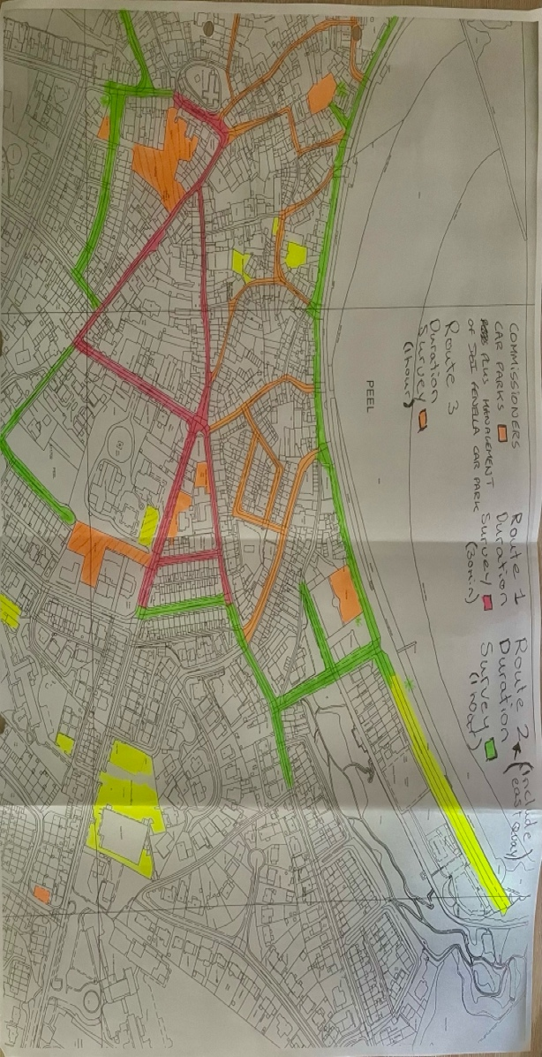
Figure 4: Occupancy Beat Surveys and Routes

Table 3 below shows all the parking areas associated with the town centre parking. These areas have undergone a more frequent beat survey as the turnover of spaces should be higher due to the restriction of vehicle parking for a length of time. The average occupancy of each area will be calculated for the period between 07:00 – 19:00, whilst other significant findings on individual areas/specific times will be commented on below. See the Appendix screenshots of where the data has been stored and calculated.

Table 3: Town Centre Associated Parking 30 Minute Beat Survey Occupancy Results (Route 1)
Name/Location: | Between 07:00 – 19:00  Average Occupancy Overtime (%)
Name/Location: | Friday | Saturday
Christian Street Car Park | 73% | 79%
Douglas Street Car Park | 85% | 89%
Car Park off Derby Road | 79% | 79%
Cathedral Car Park | 22% | 17%
Commissioners front Car Park | 75% | 83%
Derby Road | 84% | 83%
Atholl Street | 78% | 89%
Douglas Street | 60% | 63%
Market Place | 66% | 69%
Michael Street | 44% | 27%
Atholl Place | 70% | 67%
Christian Street | 80% | 83%
Mona Street | 83% | 86%

The overall average occupancy levels for the areas show a consistent level of demand on both Fridays and Saturdays. A general observation of higher occupancy on Saturdays can be noted in several locations, which reflects an increase in activity on weekends compared to weekdays. However, there are significant fluctuations in average occupancy rates, such as those on Michael Street, which are due to localized factors. This area is restricted during business hours and is a highly pedestrianized part of the town. Notably, the consistently low utilisation of the Cathedral Car Park suggests that specific restrictions, such as the honesty box policy and the no overnight stay limit, are affecting occupancy. This may warrant a review or repurposing current policy.

    - Town Centre Parking Route 1 Friday Observations
Below are graphics representing the change in the number of available spaces throughout Friday within the Town Centre. These are separated into on- and off-street parking areas associated with Peel Town Centre. These graphs will provide insights into peak usage periods, space turnover, and parking availability across the key locations.

Off-Street Car Parking
The key observations for all the off-street areas are that the total number of available spaces peaks and remains relatively high early in the day (07:00-09:00). However, shortly after, a sharp decline in availability occurs between 09:00 – 11:00, which indicates the morning peak usage for employees and visitors during the morning. Around 13:00, there is a recovery in the number of spaces, which suggests that there is a turnover in the short-stay spaces. After 16:00, the availability declines sharply, which is likely due to residents/workers returning and using spaces for residential long stay. Car-park specific points, such as Douglas Street, see a sharp drop in the number of available spaces and have a consistently high occupancy for the rest of the day. Notably, the Cathedral Car Park consistently is the highest underutilised Car Park, which suggests the requirement for investigation/policy change. On the other hand, the commissioner’s car park shows low availability throughout the day, highlighting its use for the facility and by residents around the area.

On-Street Car Parking
Key observations for the total available on-street spaces are the generalized wave-like pattern, where it peaks at 09:00, 13:00, and 17:00. These short-term fluctuations between each peak are likely reflecting the shorter duration visits and turnover in spaces, as the common restriction is 2 hours. Notably, the availability in spaces steadily declines after 16:00, eventually reaching its lowest levels around 18:00 – 19:00. This is likely due to restrictions being in place during the hours 08:30 - 17:30, suggesting residents are filling these spaces once unrestricted. Atholl Place & Street show consistent use within the earlier hours; however, availability does free up mid-morning and then stabilizes consistently. This varied demand suggests links to the services and businesses in these locations.

    - Town Centre Parking Route 1 Saturday Observations
Below are graphics representing the change in the number of available spaces throughout Saturday within the Town Centre. These are separated into on- and off-street parking areas associated with Peel Town Centre. These graphs will provide insights into peak usage periods, space turnover, and parking availability across the key locations.

Off-Street Car Parking
The key observation for the off-street is that the day starts with a moderate level of availability, with just over 40 spaces available until around 10:30 – 11:00, where the lowest level of availability is reached. A clear increase in availability is then seen Midday and onwards, which peaks around 17:00 – 17:30. This is likely due to afternoon departures/turnovers. Overall, the demand on a Saturday is quite like that on Friday, with the peak demand occurring between 09:00 and 11:00, where availability is generally at its lowest. We can also see a consistent fall in the number after parking restrictions, which is likely due to residents utilising spots for the evening.

On-Street Car Parking
The key observation for the on-street is that the number of available spaces peaks around 08:30 – 09:00, with a steep decline shortly after, whilst reflecting similar demand patterns to the off-street trends. A notable recovery occurs from 14:00 to 17:30, before dropping towards the end of the day. These patterns indicate a higher demand mid-morning, followed by turnover or reduced activity within the afternoon.

    - Promenade/Out-Skirts Town Average Occupancy
Table 4 below shows all the parking areas associated with the promenade or the outskirts of town parking. These areas have undergone a larger parking beat survey due to the length of the route, and there are a few restrictions along this route. The average occupancy of each area will be calculated for the period between 07:00 – 18:00, whilst other significant findings on individual areas/specific times will be commented on below.

Table 4: Promenade/Out-Skirts of Town Associated Parking 1 Hour Beat Survey Occupancy Results (Route 2)
Name/Location: | Between 07:00 – 18:00  Average Occupancy Overtime (%)
Name/Location: | Friday | Saturday
Church Street | 24% | 73%
Upper Christain Street | 82% | 79%
Peveril Road | 45% | 70%
Walpole Road | 54% | 92%
Shore Road | 81% | 90%
Victoria Street | 91% | 94%
East Quey | 63% | 66%
Mill Road | No Parking | No Parking
Station Road | No Parking | No Parking
Boilley Spittal | 79% | 89%
West View | 86% | 95%
Tynwald Road | 83% | 90%
Lyndale Avenue | 54% | 58%
West Quay | 68% | 75%
House of Mannanin | 73% | 73%
Marine Parade Car Park | 45% | 71%
Shore Road Car Park | 72% | 83%
Car Park off Victoria Street | 82% | 81%
Boilley Spittal Car Park | 60% | 65%

The overall average occupancy levels for the areas show a consistent level of demand on both Fridays and Saturdays, except for Church Street and Peveril Road on Friday, as restrictions on parking were in place, hence the low calculated average occupancy. A higher occupancy can be generally seen on Saturday, with many more areas reaching saturation. This calls for a significant review into the current situation, especially in tourist-related areas such as the promenade,
where demand for the average Summer Holiday exceeds the current supply.

    - Promenade/Town Outskirts Parking Route 2 Friday Observations
Below are graphics representing the change in the number of available spaces throughout Friday along the promenade and the town outskirts. These are separated into on- and off-street parking areas associated with along the route.

Off-Street Observations
The Observation for the off-street parking areas highlighted in the graphic below is that the day starts at its peak availability between 08:00 – 09:00, where there are over 90 spaces free. Notably, there is a steep decline between 09:01 – 12:00 due to high occupancy within certain car parks. After such, availability remains consistent throughout the day (12:01 – 15:00) and frees up towards the end of the day, suggesting a turnover in leisurely activities.

On-Street Observations
The observation for the on-street is that it peaks early at 08:01 – 09:00 with over 150 spaces. Notably, there is a large decline in availability between 09:01 – 13:00 as the number of spaces falls to 67. This is likely due to the increase in footfall of visitors utilising spaces with proximity to the beach. We can see a small turnover of spaces at 13:01 – 14:00, with spaces slightly recovering. However, between 14:01 – 16:00, the availability then reaches its lowest throughout the day. After reaching the end of the day, space started to make a slow recovery, which suggests this is a turnover from leisurely activities.

    - Promenade/Town Outskirts Parking Route 2 Saturday Observations
Below are graphics representing the change in the number of available spaces throughout Saturday along the promenade and the town outskirts. These are separated into on- and off-street parking areas associated with along the route.

On-Street Observations

Compared to Friday, there are generally fewer spaces throughout the whole day. This is due to Saturday being on the weekend, and with it being the school holidays, there is likely a higher demand for leisurely activities. The availability peaks early in the morning, with a peak availability of 98 spaces between 07:01 and 08:00. The spaces then start to decline slowly, but recover slightly between 09:01 and 11:00, suggesting that residents have vacated the spaces for work or leisure. Then the decline continues to fall to its lowest point from 11:01 – 16:00, with only 25 spaces available. This is likely the peak period for visitors to the leisure services along the seafront. With a consistent turnover towards the end of the day between 16:01 – 18:00, with visitors leaving and residents returning.

Off-Street Observations
We can see the occupancy for the off-street car parks starts very similar to Friday, with the total available spaces peaking at 08:01 – 09:00 (94 spaces). However, unlike Friday, there is a steep decline in the number of spaces from 09:01 – 14:00, which is due to visitors occupying throughout the day and staying parked for longer hours. Between 13:01 – 15:00 is where the fewest number of spaces at only around 10 spaces, with notable occupancy for the Marine Parade, which was underutilised on the Friday. There is a very slow recovery from 15:01 – 18:00, and turnover. This is likely due to more parking being related to the evening business activity.

    - Other Parking Areas Within the Scope of the Town Average Occupancy

Table 5 below shows all the other parking areas within the scope for the beat surveys. These areas have undergone a larger parking beat survey due to the length of the route, and there are a few restrictions along this route. The average occupancy of each area will be calculated for the period between 07:00 – 19:00, whilst other significant findings on individual areas/specific times will be commented on below.

Table 4: Other Parking Areas Within Scope of Town 1 Hour Beat Survey Occupancy Results (Route 3)
Name/Location: | Between 07:00 – 18:00  Average Occupancy Overtime (%)
Name/Location: | Friday | Saturday
Stanley Road | 74% | 87%
Mount Circular Road | 73% | 82%
Stanley Mount | 68% | 73%
Bridge Street | 59% | 65%
Factory Lane | No Parking | No Parking
Beach Street | 87% | 87%
Strand Street | 99% | 94%
Strand Street Car Park | 67% | 90%
Market Street | 96% | 96%
Crown Street | 87% | 60%
Castle Street | 46% | 69%
St Peters Lane | No Parking | No Parking

The overall average occupancy levels for the areas indicate a consistent demand on both Fridays and Saturdays. Most of these areas are typically associated with residential zones. A general trend of higher occupancy on Saturdays can be observed, as hypothesized. This suggests the need for further review to determine if some of these areas are at saturation and rarely experience turnover due to permits or lack of restrictions.

    - Other Parking Areas Within the Scope of the Town Friday Route 3 Observations

Below are graphics representing the change in the number of available spaces throughout Friday in the areas of the town listed above. As there is only one off-street parking area along this route, separate graphics will not be created and instead will be combined.

Observations
For the highlighted areas in route 3, we can see that the number of spaces fluctuates throughout the day. We can see that during the morning, between 08:01 – 09:00, and 10:01 – 11:00, there is a peak in the availability of spaces. However, the highest availability was between 12:01 – 13:00, which suggests a potential mid-day dip in demand for parking. After 13:00, the availability steadily declines and reaches its lowest point by 17:00 with 19 spaces, and remains this way until 19:00. This is likely due to residents returning and the end-of-day visitors arriving back. The overall complexion of the graph suggests that there is a commuter pattern of residents leaving early in the morning and returning early evening.

    - Other Parking Areas Within the Scope of the Town on Saturday
Route 3 Observations

Below are graphics representing the change in the number of available spaces throughout Saturday in the areas of the town listed above. As there is only one off-street parking area along this route, separate graphics will not be created and instead will be combined.

Observations
The general trend for a Saturday is that availability generally starts the day at its lowest (07:00 – 09:00). We can then note a steady increase in the total number of available spaces, where it reaches its peak of 40 spaces around 14:01 – 15:00, this suggest that there is a lower demand for parking in these areas during the afternoon. Notably, the availability declines slightly from 16:01 – 17:00, likely due to residents returning from activities. With a final uptick at the end of the day, where total available spaces are 30.

    - Overall Summary of Data Collected and Results
Town Centre Parking (Route 1) had average occupancy ranging between 17% to 89%, which suggests the need for targeted redistribution in areas with key proximity to the town centre to underutilised areas. The off-street areas along this route showed consistent declines in availability around 09:00 and late afternoon, which suggests commuters and residential use. However, the on-street areas showed consistent turnover and short-stay use up until the point at which they are restricted.

Promenade and Outskirts Parking (Route 2) had many areas nearing saturation, especially on Saturday, with 9 out of 16 areas having an average occupancy of greater than 75%. Both areas saw peak occupancy and demand around mid-morning and early afternoon. There is a notable difference in the level of demand on Saturday compared to Friday, especially in areas close to the Promenade. This is most likely driven by tourism/visitors and leisurely activities, as it was the school holidays. Generally, for all areas, peak occupancy was noted at 11:00 and 16:00, with the fewest number of spaces being available.

Other Town Areas (Route 3) had a generally high average occupancy, especially within the residential areas. Friday showed the usual commuter-style occupancy with spaces available through the day, but declined towards the evening. Saturday showed a steady increase in availability throughout the day and eventually declined in the evening. The constant occupancy and limited turnover are due to the unrestricted nature of parking and permit-based stays.

  - Other Comments/Observations
Separate occupancies were calculated for designated spaces, such as disabled and electric, to assess whether there is a higher demand for more of these spaces. The average occupancy for each type will be an average for the whole survey period. Table 6 below highlights the locations within the Town Centre which have Disabled spaces, whilst outlining the occupancy of these spaces on each day.

Table 5: Occupancy Table for Disabled Parking Bays
Name/Location: | Between 07:00 – 19:00  Average Occupancy Overtime (%)
Name/Location: | Friday | Saturday
Douglas Street Car Park | 41% | 49%
Commissioners front Car Park | 29% | 29%
Atholl Place | 42% | 31%
Marine Parade | 5% | 27%
Shore Road Car Park | 14% | 27%
Shore Road | 55% | 77%
East Quay | 55% | 42%
House of Manannan | 70% | 39%
With most bays on average being largely underutilised, these areas should be considered and reviewed for accessibility issues, poor signage/marking, or relocation to areas with higher demand, such as shore road.

Table 6 below highlights the electric pod points within the town centre and Promenade, while outlining their average occupancy for a Friday and Saturday.

Table 6: Occupancy Table for Electric Parking Bays
Name/Location: | Between 07:00 – 19:00  Average Occupancy Overtime (%)
Name/Location: | Friday | Saturday
Market Place | 25% | 23%
Commissioners front Car Park | 39% | 34%

We can note that these are currently underutilised, which is likely due to the slow integration of electric cars, and noting that most residents in Peel have charging points set up at their residences. Due to this low utilisation, the proposal for more e-points should be considered for the long term.

3 Policy Development and Recommendations

  - Introduction
    - This Chapter will outline the data-driven and realistically implementable parking policies to improve the management of car parking within the Town Centre and Promenade of Peel.

    - The flow of this section will follow the order of the routes undertaken and will underline policy recommendations that will be categorised into short-term (within the next year) and long-term (Between 2 – 10 years), highlighting what should be considered for the future and what should be in effect as soon as possible.

  - Town Centre Recommendations
Short-Term Policy Recommendations
Increase Parking Restrictions to Improve Turnover within the Evening
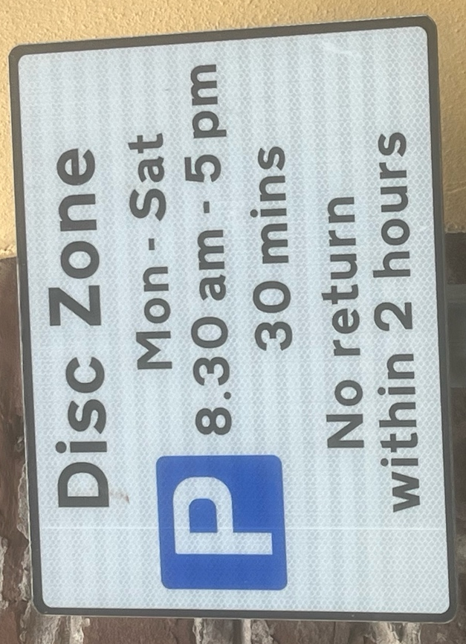
    - The first proposal for the town centre is to extend the duration of parking restrictions to support the town's night economy. These areas would be Atholl Place and Christian Street, where there is high demand for parking due to numerous hospitality venues. Data shows that between 2:30 PM and 7:00 PM, parking spaces are very limited. Currently, residents likely use these spots in the evening because restrictions only apply from 8:30 AM to 5:00 PM, allowing for overnight parking. Extending the restrictions to 8:30 AM – 7:30 PM is expected to improve turnover and enable more customers and employees to use these spaces for delivery. This change would also reduce illegal parking, especially on Christian Street, where 19 illegal parking incidents were recorded on Friday and Saturday. These are probably caused by delivery drivers and customers parking for direct access to the hospitality venues. The policy aims to balance the need for resident parking and access for key hospitality businesses for employees and customers within trading hours.
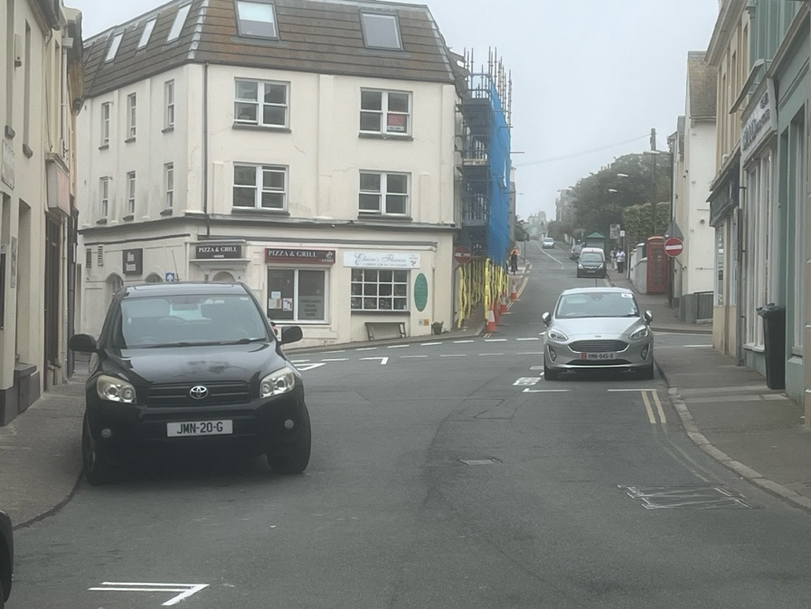

Clearer Signage and Review of Current Policy for Car Park off Derby Road
    - There are several spaces available throughout both days, between 12:00 and 17:00, averaging about 20 spaces every half-hour. Many of these spaces are either designated for residents or reserved for the police, which calls for a review of whether the number of designated spaces should be changed or the hours they are reserved. I suggest decreasing the number of spaces allocated for the police to a minimum of three and checking with residents if they are parking in other areas to either reallocate or remove designated spaces to allow them to be used for shorter turnover periods. This change would help protect residential spaces while increasing visitor parking during the daytime. By making this adjustment, Peel Town Centre can improve its turnover by making better use of existing facilities, without requiring infrastructure development.

Relocation of Loading Bay from Douglas Street to Atholl Place
    - Currently, within the Town Centre, the main loading is in the Douglas Street Car Park and is regularly used by Tesco and Co-op for unloading goods. A second loading bay was established on Douglas Street as a backup facility and was mainly utilised by the old post office. However, due to the move of the post office and unclear road markings, residents are likely using this area to leave their vehicles and park. I suggest that this area return to being parking spaces for some of the residents along that street. Secondly, there is a demand within Atholl Place for a designated loading facility for the local businesses. During my occupancy surveys, I noted delivery vehicles unloading right before the give-way junction or using the disabled bays.

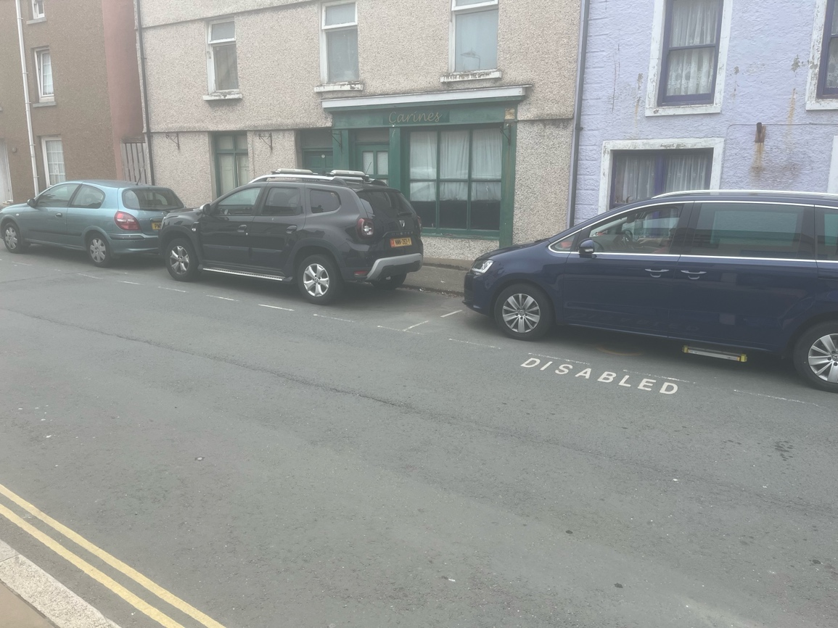

Long-Term Policy Recommendations
Pay and Display Parking for Douglas Street Car Park
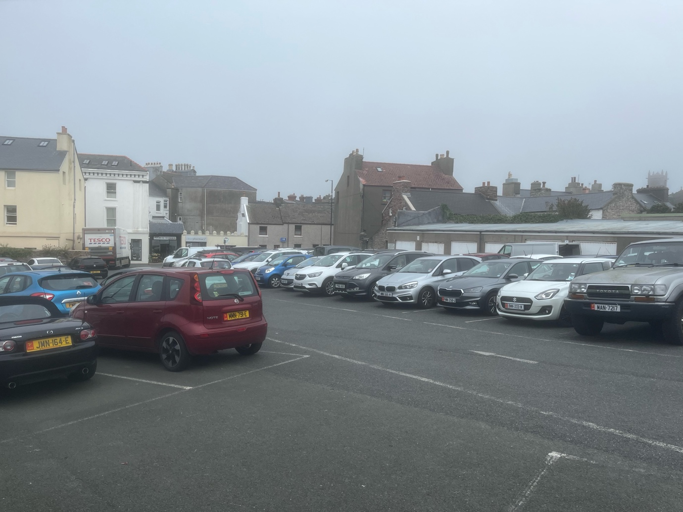
    - The survey data highlights that the Douglas Street Car Park consistently experiences the highest level of occupancy across both Friday and Saturday. This sustained high level of demand outlines the importance of the location for the car park in supporting the town centre economy. The high occupancy indicates that the current free parking arrangement is not effectively turning over vehicles. I propose that Pay and Display parking should be implemented, with a similar structure to the Sea Terminal and Chester Street Car Parks in Douglas. Where the first hour of parking is free of charge, and any hours of parking after such should incur a charge. This strategy would align with the best interests of the town centre’s economic goals by making more convenient spaces available to visitors. With this form of sustainable revenue, the Commissioners could pay for adequate enforcement and potentially help fund infrastructure investments.

Infrastructure developments within Derby Road, Douglas Street, and Atholl.

    - The survey findings indicate that occupancy levels across some of the key areas within the town centre are remaining consistently high. This sustained demand and expected increase in visitor numbers signal a future capacity shortage in parking spaces near the town centre. Targeted infrastructure development in areas such as Derby Road Car Park, Douglas Street Car Park, and Atholl Street would increase overall capacity, while also supporting local businesses within the area. For Douglas Street, vertical expansion should be considered, as this would allow this area to maximise capacity without the need for increasing the land footprint. For areas such as Atholl Street and the Derby Road Car Park, conversion of underutilised land should be considered and structured into surface parking spaces, for example, the old Telephone Exchange is currently only utilised and used by Manx Telecom to park vehicles.

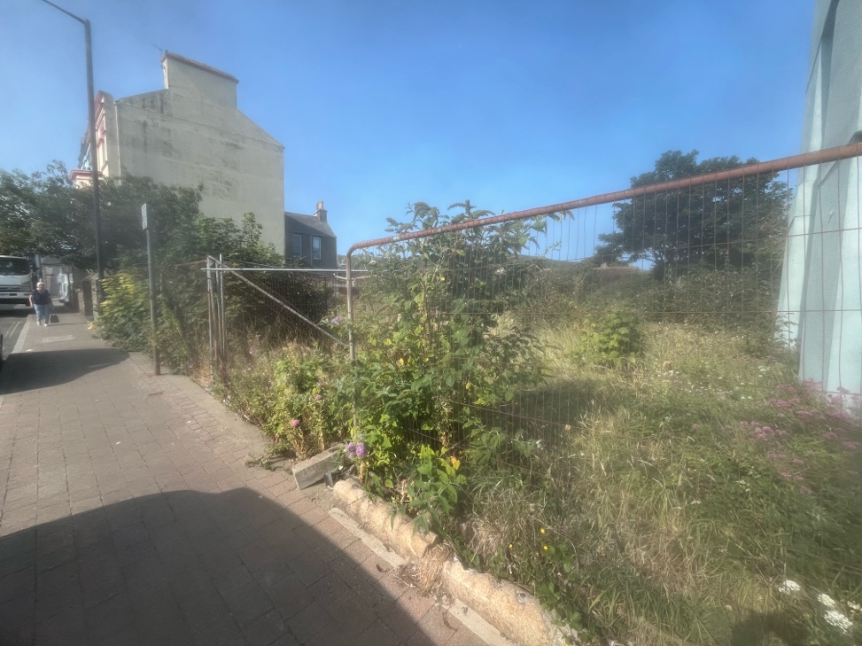
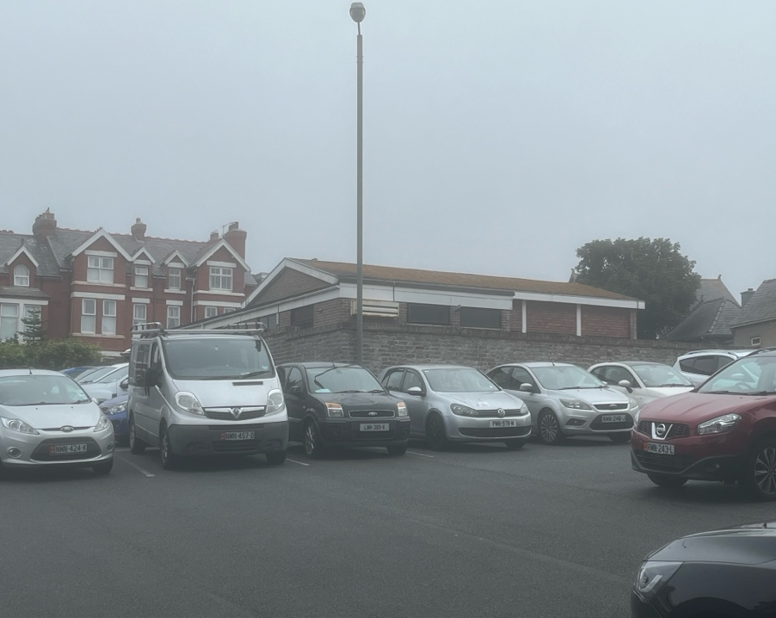

  - Promenade and Town Outskirts Recommendations
Short-Term Policy Recommendations
Re-open and Expand West Quay Car Park
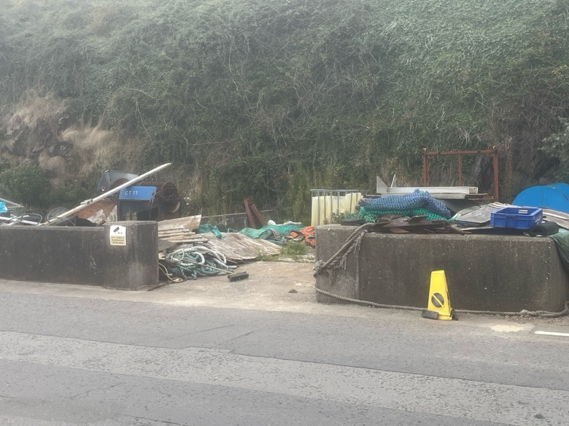
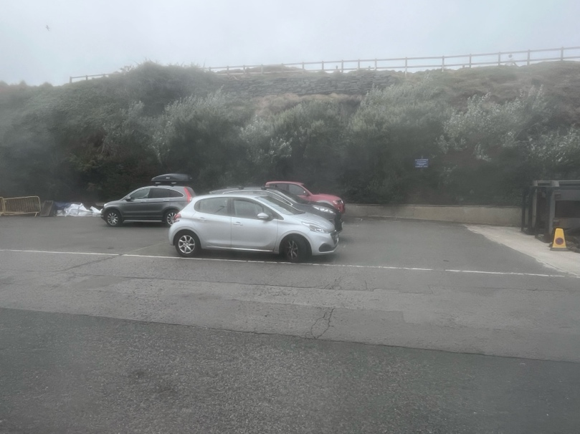
    - During the survey, notable use of the West Quay car park was spotted specifically on Saturday, despite its current poor condition and partial utilisation for purposes other than parking, such as storing of fishing equipment. Furthermore, the presence of this equipment is reducing the total capacity and causing more vehicles to park roadside, and contributing directly to congestion. I propose relocating the equipment to the designated storage areas near the House of Manannan. For the current boats, this would allow West Quay Car Park to be extended through a minor land reclamation and repurposing. This would not only improve the aesthetic of the area but also provide a low-cost intervention and improve the economic activity.

Introduce a designated campervan park in under-utilised areas (Marine Parade).
    - During the survey, across both Friday and Saturday, at least 10 Campervans were present throughout the whole day along the West Quay. This demonstrates the attractiveness that these areas have for long-stay visitors, and it also highlights the ongoing issue where large vehicles are occupying several spaces for extended periods, which is reducing the available spaces for shorter turnover periods. I propose a relocation strategy for these vehicle types to the end of Marine Parade. This would involve reconfiguring the area to outline bays for these vehicles and provide sufficient signage to highlight this area. Establishing this designated facility would offer a strategic and visitor-friendly solution that will improve the management of parking resources, especially along the West Quay. During the survey, I noted that this area was utilised by some motor homes.
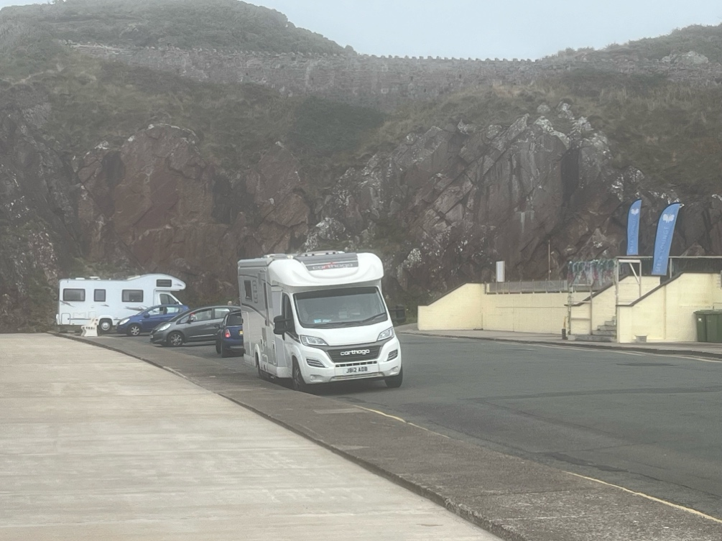

Combination of Short-term and Long-term Policy
Repaint and Outline Road Markings (Bus Stops) Short-Term
    - During the surveys, observations were noted that vehicles were parking for long durations in designated stopping areas for buses along the Promenade along Shore Road. These bays were intended to be utilised to pick up and drop off passengers; however, evidence suggests they are being used by private vehicles, creating congestion on the road. This is likely due to unclear or faded road markings, which do not make the restriction visually obvious for drivers. I propose the action to repaint the road markings with clear high-visibility colours such as white or yellow to outline the designated area. By improving these road markings, this will reduce congestion along Shore Road and allow these bus zones to be functional and safe for users.
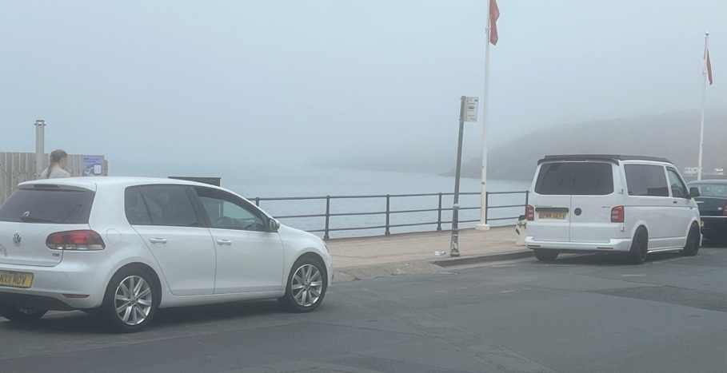

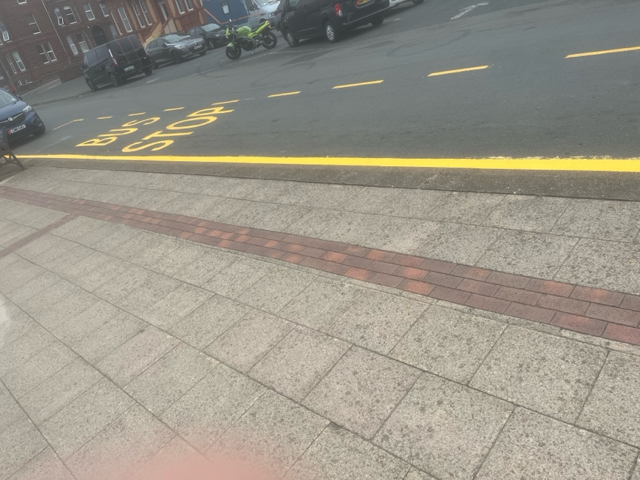

Introduce zoned loadings facilities along the Promenade and Shore Road Short-Term
    - During the survey observations along the Promenade and Shore Road that delivery vehicles were creating notable congestion on the roads. As illustrated below, large vans and delivery vehicles can be seen occupying parts of the carriageway during unloading, and this is forcing drivers to navigate around them within restricted spaces.
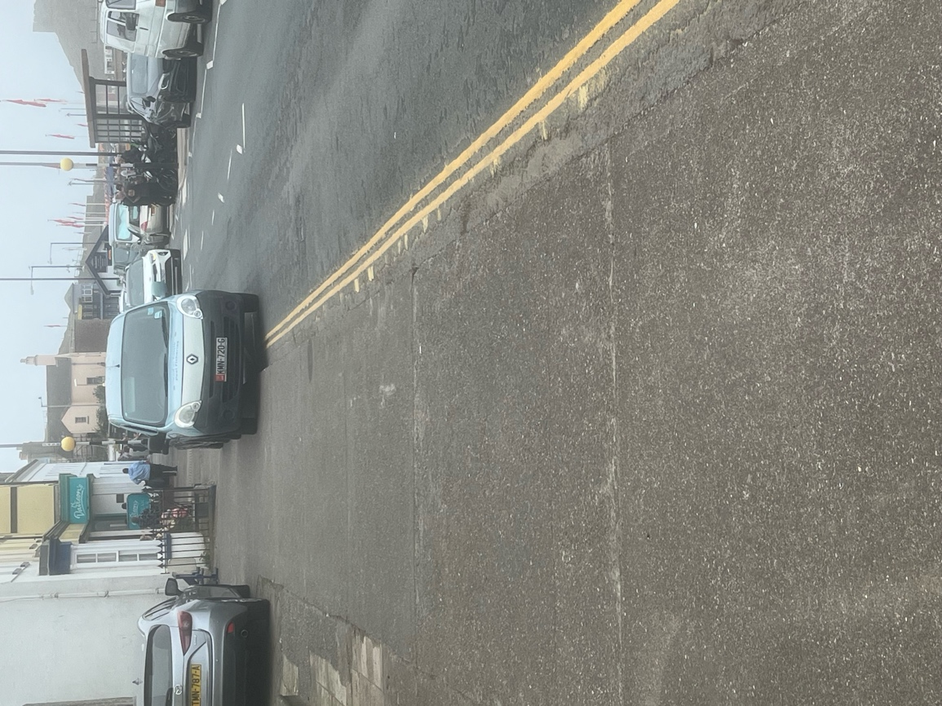
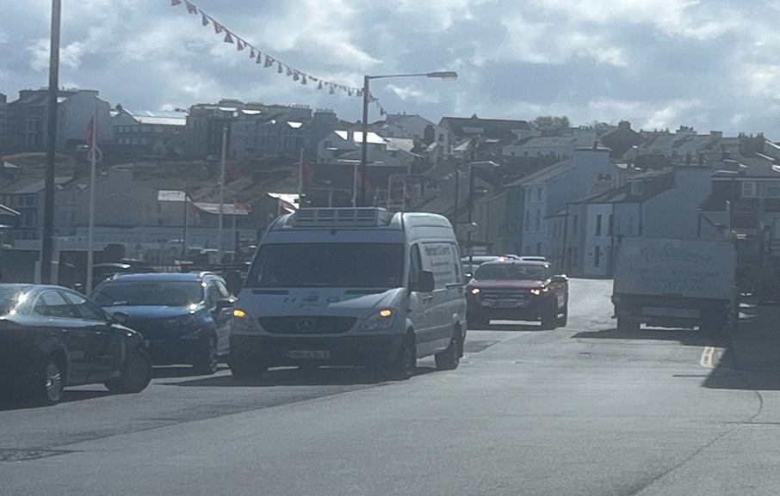

This is likely due to two underlying reasons: narrow road widths and a lack of designated loading/unloading facilities in proximity to the businesses in this area. Introducing zoned facilities would allow businesses to receive goods efficiently without disrupting the flow of traffic. These areas can be strategically placed to serve multiple businesses in the area.

Introduction of a one-way system along East Quay and Promenade Long-Term
    - The current two-way traffic setup along these routes requires vehicles to slow down or stop completely due to unloading and loading activities. This problem is especially common during the summer months when many visitors access the Promenade. As a result, parking demand in these areas is nearly full. Implementing a new one-way system would improve traffic flow, particularly in narrow sections of the road. It would also optimize kerb spaces along the Promenade, increasing overall on-street parking and attracting more visitors to the town. Important considerations include consulting with local businesses, residents, and public/private transportation operators to determine accessibility and routing. Clear signage and road markings should be installed to guide all users. Additional studies are recommended to assess the potential impact on surrounding roads, ensuring the new traffic system doesn't cause congestion elsewhere. Transforming the East Quay and Promenade into a one-way system would promote Peel’s economic growth and tourism appeal.

  - Conclusion
    - By considering and implementing the following recommendations outlined within this chapter, I believe Peel Town can take significant steps to achieve a more efficient, accessible, and sustainable parking system for the town. The proposed recommendations will address both short-term issues and long-term strategic goals.

    - The actions above aim to be realistic and implementable for the town. These actions seek to improve the overall traffic in the town and enhance the availability of spaces/facilities for residents, visitors, and businesses. By balancing the needs of these different stakeholders, the Peel Town Commissioners can ensure that current parking areas support the economic activity, especially during the evening and tourism seasons.

    - By accommodating these recommendations, Peel Town will improve its turnover of parking spaces, whilst being able to accommodate future seasonal growth in demand. This will also enhance the parking environment for residents, commuters, visitors, and businesses.
Appendix:
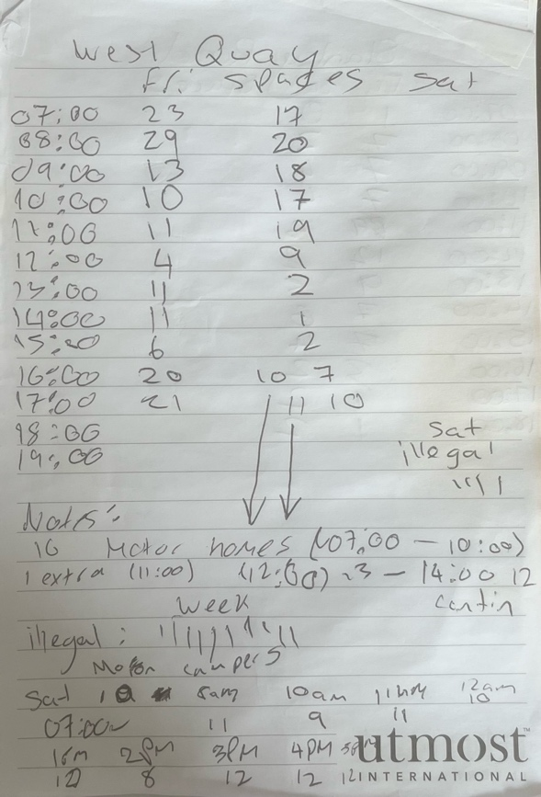
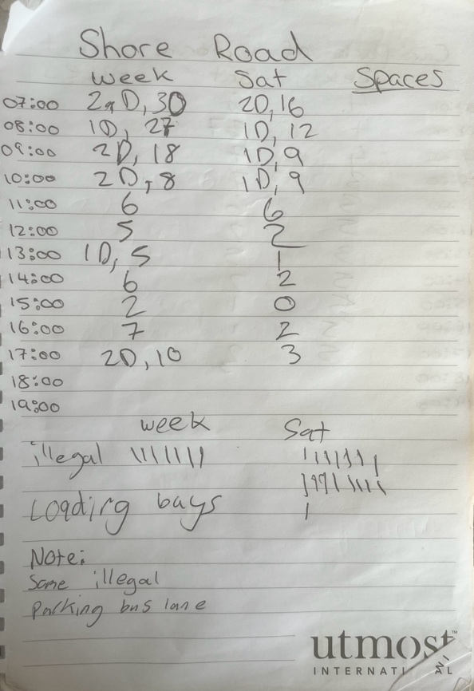
Notes Taken During Surveys of Promenade

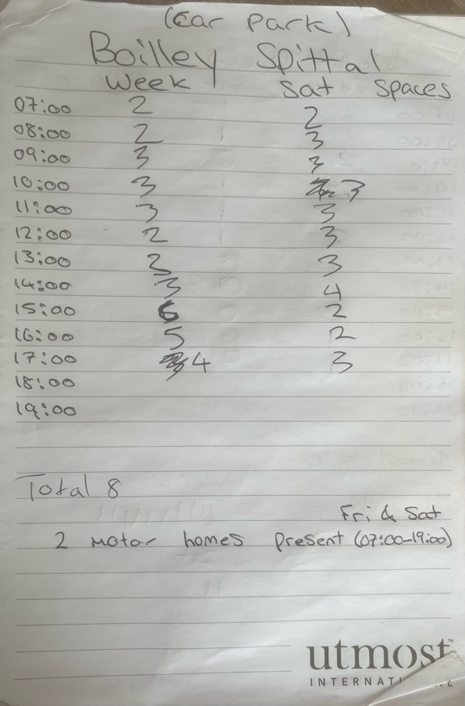
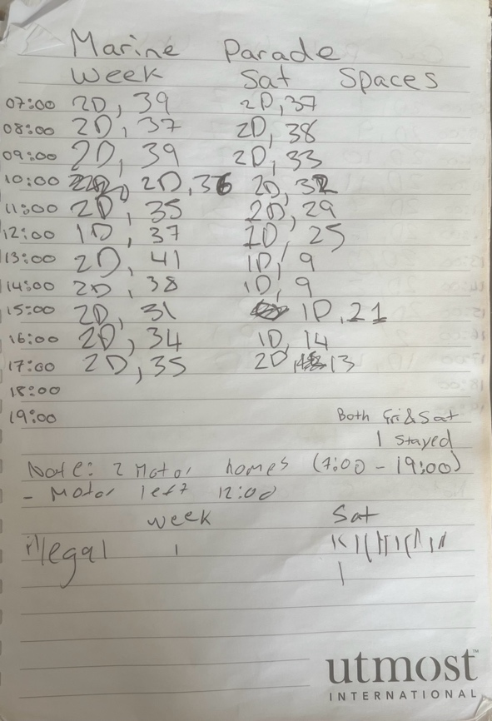

Bibliography:
3FM (2024). Medical Centre warns Peel residents over parking. [online] 3FM. Available at: https://www.three.fm/news/isle-of-man-news/medical-centre-warns-peel-residents-over-parking/ [Accessed 1 Jul. 2025].
Alpha Parking (2022). Parking Beat Survey - Alpha Parking. [online] Alpha Parking. Available at: https://www.aparking.co.uk/parking-surveys/parking-beat-surveys/ [Accessed 15 Jul. 2025].
amey (2013). Peel Town Centre Parking Study and Parking Policy Development Options. [online] Www.gov.im. Available at: https://www.gov.im/media/951289/peel_parking_study_-_co03022416_fr_04__inc_apps__-_final_report_feb_2013....pdf [Accessed 1 Jul. 2025].
Burnley.go.uk (2010). Car Parking Strategy. [online] file:///Users/jamiecasson/Downloads/Item_13_CDC_Parking_Policy_and_Strategies_Update___Appendix_1.pdf
Gov.IM (2016). Strategic Plan. [online] Available at: https://pabc.gov.im/strategicplan [Accessed 30 Jun. 2025].
Gov.im (2018). Parking Restrictions. [online] Www.gov.im. Available at: https://www.gov.im/media/1368672/parking-restrictions-guidance-document.pdf [Accessed 11 Jul. 2025].
Gov.im (2024). Isle of Man Government - Optimistic economic growth forecast for the Isle of Man. [online] Www.gov.im. Available at: https://www.gov.im/news/2024/dec/30/optimistic-economic-growth-forecast-for-the-isle-of-man/ [Accessed 1 Jul. 2025].
Gov.UK (2022). Private Parking Code of Practice. [online] GOV.UK. Available at: https://www.gov.uk/government/publications/private-parking-code-of-practice/private-parking-code-of-practice.
Hagman, O. (2006). Morning Queues and Parking Problems. On the Broken Promises of the Automobile. Mobilities, 1(1), pp.63–74. doi:https://doi.org/10.1080/17450100500489247.
Hertsmere.gov.uk (2022). Hertsmere Borough Council Parking Management Strategy. [online] Available at: https://www.hertsmere.gov.uk/Documents/10-Transport--Streets--Parking/Transport/Parking-management-strategy-Sep-2022.pdf [Accessed 14 Jul. 2025].
IHT, 2005. Parking Strategies and Management. Institution of Highways and Transportation, HQ Media Services Ltd, Essex, ISBN: 0 902933 36 1.
isleofman.com (2007). Parking problems in Peel. [online] Isle of Man. Available at: https://www.isleofman.com/news/view/21969175/parking-problems-in-peel.
Keswick Town Council (2020). Keswick Transport study. [online] https://keswicktowncouncil.gov.uk/wp-content/uploads/2020/01/Keswick-Transport-Study-Report.pdf
legislation.gov.im (2025). Town and Country Planning (Permitted Development) Order 2025 Index c. [online] Available at: https://www.legislation.gov.im/cms/images/LEGISLATION/SUBORDINATE/2025/2025-0027/2025-0027.pdf [Accessed 3 Jul. 2025].
Legislation.gov.uk (1988). Road Traffic Act 1988. [online] Legislation.gov.uk. Available at: https://www.legislation.gov.uk/ukpga/1988/52/contents.
Manx Radio (2023). Motoring and illegal parking at top of the west’s neighbourhood issues. [online] Manx Radio Motorsport. Available at: https://motorsport.manxradio.com/news/isle-of-man-news/motoring-and-illegal-parking-at-top-of-the-wests-neighbourhood-issues/ [Accessed 1 Jul. 2025].
Morency, C. and Trépanier, M. (2008). Characterizing Parking Spaces Using Travel Survey Data Characterizing Parking Spaces Using Travel Survey Data. [online] Available at: https://www.cirrelt.ca/documentstravail/cirrelt-2008-15.pdf.
Parmar, J., Das, P. and Dave, S.M. (2020). Study on demand and characteristics of parking system in urban areas: A review. Journal of Traffic and Transportation Engineering (English Edition), [online] 7(1), pp.111–124. doi:https://doi.org/10.1016/j.jtte.2019.09.003.
Pasaoglu, G., Fiorello, D., Martino, A., Scarcella, G., Alemanno, A., Zubaryeva, A. and Thiel, C. (2012). Driving and parking patterns of European car drivers ---a mobility survey. [online] doi:https://doi.org/10.2790/7028.
Perri, G. and Vaiana, R. (2022). Road Safety Management of Uncontrolled Access Points: Design Criteria and Insights into Risk Factors. Applied Sciences, [online] 12(24), p.12661. doi:https://doi.org/10.3390/app122412661.
S. S. Dey, M. Darst, A. Pochowski, B. O. Pérez, and E. C. Sanchez, “Hunt for perfect detection of parking occupancy: Evaluation of on-street technology and its ability to address urban challenges,” Transp. Res. Rec., J. Transp. Res. Board, vol. 2645, no. 1, pp. 12–23, Jan. 2017.
Silderhuis, H. (2013). On-street and Off-street parking. [online] www.parking.net. Available at: https://www.parking.net/about-parking/on-and-off-street-parking.
Tong, C.O., Wong, S.C. and Leung, B.S.Y. (2004). Estimation of parking accumulation profiles from survey data. Transportation, [online] 31(2), pp.183–202. doi:https://doi.org/10.1023/b:port.0000016579.36253.a9.
TrafficWatch (2020). Parking Beat Surveys - Traffic Watch. [online] Trafficwatchuk.co.uk. Available at: https://www.trafficwatchuk.co.uk/parking-beat-surveys.php.
Transport Planning International (2011). PARKING STUDY, PUBLIC TRANSPORT AUDIT AND PARKING POLICY DEVELOPMENT OPTIONS FOR RAMSEY TOWN CENTRE. [online] Www.gov.im. Available at: https://www.gov.im/media/951295/ramsey_parking_study_and_public_transport_audit_inc_figs_and_app.pdf.
Yan, X., Levine, J. and Marans, R. (2019). The effectiveness of parking policies to reduce parking demand pressure and car use. Transport Policy, 73, pp.41–50. doi:https://doi.org/10.1016/j.tranpol.2018.10.009.
Yates, F. (1948). Systematic Sampling. Philosophical Transactions of the Royal Society A: Mathematical, Physical and Engineering Sciences, [online] 241(834), pp.345–377. doi:https://doi.org/10.1098/rsta.1948.0023.
Young, W., Thompson, R.G. and Taylor, M.A.P. (1991). A review of urban car parking models. Transport Reviews, 11(1), pp.63–84. doi:https://doi.org/10.1080/01441649108716773.

